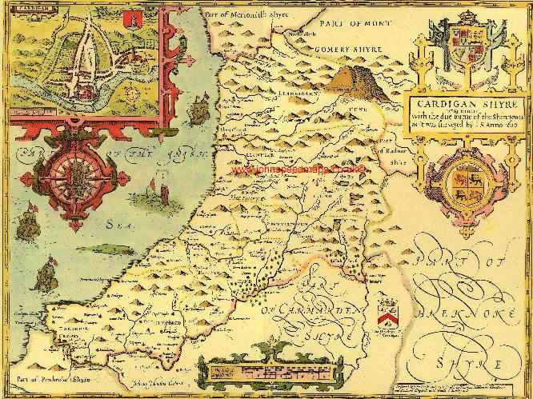

Finzi Trust Scholarship 2017

The Lost Songs of Ceredigion – Uncovering West Wales’ Folk Music Heritage
by Owen Shiers

Contents

1. Overview
2.Key People
3. Key Sources
3.1 Singers
3.2 Archived Field Recordings
3.3 Welsh Folk Song Society Journals
3.4 Ballad Sheets
3.5 Books
3.6 Collections
4. Further Musical Analysis
5. Conclusions
6. List of Songs
7. Bibliography

1.Overview
As with many things in life, the journey you end up taking often differs to the one you initially envisage. This certainly proved the case with my Finzi scholarship. Although I had planned my trips and had a fair idea of the areas which I intended to exlore, I had not anticipated the challenges of travelling such long distances and discoveries which would lead down many a rabbit hole. On more than one occasion I extended a visit in order to visit a new contact or read a book in its entirety in the National Library. I also visited more people than anticipated and as such made more trips to Wales than originally intended. As such I essentially had to throw my planned schedule out of the window and respond more flexibly in order to make best use of opportunities as they arose – combined with the exigencies of earning a livelihood, this resulted in my scholarship taking much longer than originally intended.
My mission statement was to research and collect lost or rare folk songs from Ceredigion, West Wales including the area in which I grew up. Through this I hoped to return to my roots, uncover more of my own heritage and perhaps add something to the nation’s cultural treasure trove. Growing up in the small village of Capel Dewi, I was aware of many local traditions, songs and customs but only as I began delving more deeply did I begin to realise the true cultural richness of this part of Wales.
Unfortunately what also became apparent during my work was to the extent to which interest in these traditions is waning. The majority of the people I interviewed and spoke to were over 70 years old and there seems very little interest from the younger generations - indeed some ancient singing styles such as ‘Canu Pwnc’ are on the verge of extinction. This realisation added a sense of urgency to my work and as I went about meeting people I had the distinct sense that I was catching the glimpse of a cultural landscape which may look very different in twenty years time.

2. Key People
My initial ‘hit list’ contained four authorities on Welsh folk music – Ceri Rhys Matthews, Phyllis Kinney, Roy Saer and Daniel Huws. Unfortunately it transpired that the author and scholar Phyllis Kinney is now suffering from dementia and unable to receive visitors but I received a wealth of knowledge, information and leads from those who I did visit. I ended up visiting eight people of varying backgrounds, all of whom were immensely helpful.
Roy Saer
Roy Saer was my first port of call. As the chief audio archivist and recordist at St. Ffagan Museum of Folk Life for over forty years he has a wealth of knowledge, and at 80 is still in great demand. Roy was incredibly generous in providing me with an exhaustive and detailed list of research points for folk music in Ceredigion and this list quickly became my ‘go to’ bible. We also discussed singing styles, which was not something I had considered – in particular ‘Canu Pwnc’ or ‘Topic Singing’ which is a very ancient and unusual style of singing used to learn religious scriptures. Whilst technically not a ‘folk’ tradition he urged me to find some recordings and to try to seek people who knew of it, or even better could still sing it.
Daniel Huws
My intent during my first trip to the Welsh National Library in Aberystwyth was to begin researching some of the leads which Roy Saer had given me and to also enquire about a contact for Daniel Huws, the former folk music archivist at the library. As fate would have it, he happened to be visiting the library on the same day as I and we managed to have a chat about my research. Daniel is now in his mid eighties and unfortunately at times gets a bit confused, but he did tell me about the Ifor Ceri collection of folk melodies from the 18th century (some of which were from Ceredigion) which has recently been digitised. I was able to access this online and browse through the tunes in my own time from home which was a great help. Daniel also helped locate of some of the original manuscripts which were used for the journals of the Welsh Folk Song Society.
On a personal level, Daniel’s concerns around the future of folk music in Wales left an impression. He was greatly worried that improvements in access and technology would not be enough to sustain interest in Wales’ folk traditions, but he was encouraged that there was at least one young person taking an interest in the field. If nothing else, our time talking spurred me on to learn as much as I could.
Ceri Rhys Matthews
Unlike my other contacts who were all academics, Ceri is an active musician, and in his fifties, seemingly still a spring chicken in the Welsh folk world! Ceri plays flute and guitar with his band Fernhill and has also conducted extensive research into the folk music of Wales. A collection which Ceri has spent much time studying is the J. Ffos Davies collection from south Ceredigion which dates from the turn of the last century. He strongly urged me to get hold of a copy of the rare book – ’40 Cardiganshire Tunes’ (Cardiganshire being an anglicised name for Ceredigion) which has the only published copies of his collection. Ceri also told me of Myra Evans’s rare collection of folk music and tales, which is also in the National Library.
Eleri Davies
A retired family friend, author and historian. Eleri was immensely helpful in supplying me with the titles of some specialist local books. She also put me in contact with the two ballad singers who I interviewed and recorded, as well as a relative of Kate Davies (see later note). Eleri was very much enthused by the work I was doing, still phoning me with ideas and sending books as late as January. I also very much enjoyed conversing with her in our ‘tafodiaith’ or local dialect, on which she corrected me on more than one occasion!
Robyn Tomos
A retired local singer and friend of Eleri Davies, Robyn was a big help in giving me copies of the J. Ffos Davies collection as well as connecting me to the work of Tegwyn Jones, who has researched extensively into the field of ballad singing in Wales during the 18th and 19th centuries.
Wenna Bevan Jones
Another family friend and historian who allowed me access to her late husband’s extensive library, where we found a handful of out of print books containing songs. One book of ballads and songs in particular Teifi was nearly 200 years old and most certainly should have been in the National Library!
Edgar Thomas
A relative of Eleri Davies and nephew of Kate Davies, Edgar was full of stories and history of local songs and traditions. At 86, he no longer felt very comfortable singing but was able to fill in some gaps in relation to the work of what is extant of Kate Davies’ work as well as giving me the titles of some rare books of local songs – particularly those of Sarnicol (or Thomas Jacob. )
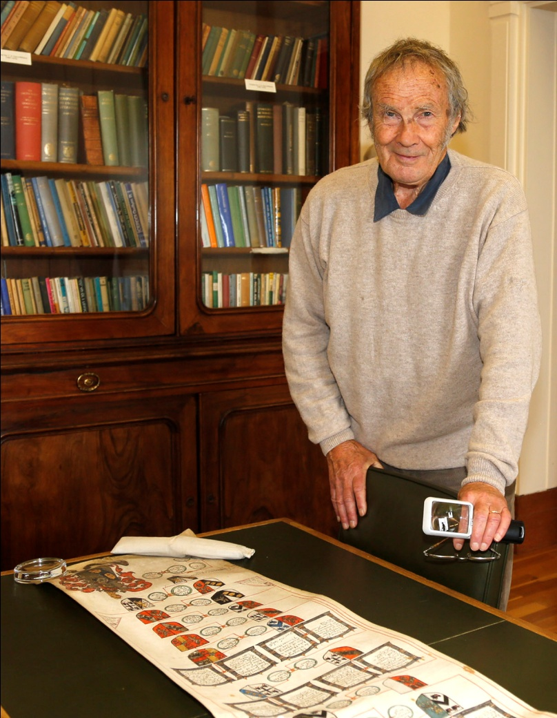
Fig. 1 – Daniel Huws at the National LIbrary

3. Key Sources
3.1 Singers
I succeeded in interviewing two local folk singers during my trips, which was a great opportunity to see if there was still material extant in oral tradition which had not been recorded. It also turned out to be a great opportunity to meet some real characters and I very much enjoyed my time interviewing them both. Although some of the songs they sang were well known, I’m fairly certain there were a handful which have never been recorded.
Iwan Bwlchyfadfa
At 74 years young, Iwan has yet to retire and still works potting trees in a local nursery. By night he takes part in various ‘Noson Lawen’ which is a popular format of light entertainment in Wales. It was in many ways as if he had stepped straight out of the 19th century. He was traditionally dressed and when singing stood with his hand at his breast (as per the ballad singers of old).
Although he was a little uncertain at first about me recording him singing, he did sing me five songs, three of which I had not heard before – ‘Dafydd Jones o Fwlch Y Llan’, ‘Y Crywdryn’ and ‘Yr Hen Feinar’. Iwan told me that his Mother had sung ‘Dafydd Jones o Fwlch Y Llan’, but he had forgotten some of the words until he managed to find them in an old book of ballads from Lampeter . Thankfully he could still remember the melody. The song is a tribute to a local character of old, Dafydd Jones, who used to travel the country with a cart selling various wares. He once bought a house with a side shed, but discovered that his cart would not fit through the door to the shed and resorted to taking the whole door frame off each time he put it away!
‘Y Crwydryn’ or ‘The Wanderer’ was a little different in that Iwan had come across the words in same book from Lampeter - ‘Cerddi Jac Oliver’. He had had liked the words, which were quite religious in nature and composed a simple melody them. He said that this often happens to poems and reminded me that the verb for singing in Welsh ‘canu’ applies both to music and to narrating poetry. ‘Yr Hen Feinar’ was quite Victorian in style and tells the sad story of an old lead mine near Aberystwyth.
During the conversation, Iwan also whistled and sang some nursery rhymes and ditties which he remembers his Mother and Grandfather singing. Some of them were familiar to me and others not. Although very simple and not musically of much interest, some of the words were in English – something which Iwan believed stemmed from the period when his Grandfather was in school (circa 1880’s) and receiving his education in English. This ties in with records of the late 19th century when Welsh was banned from schools and the playground, with some children being beaten for speaking their mother tongue.
Calfin Griffiths, Llanfihangel Ar Arth
Calvin is in his late sixties and often performs with Iwan at Noson Lawen, singing songs and performing various skits. Unlike Iwan, Calfin needed little encouragement and had no problems taking me through his vast repertoire, which I was able to record. Calfin must have sung to me at least 25 songs as well as reciting various poems. He had two files full of songs which he had collected over the years, many of them were well known and I was able to join in on more than one occasion. A handful of them I did not know, most notably ‘Cerdin’, ‘Y Garreg Wen’ and ‘Y Filltir Aur’.
Cerdin was a fairly simple tune and melodically the rhythm was intended to emulate the movement of water. It is lyrically quite beautiful and tells of the journey of the river Cerdin near Llandysul at it travels to meet the river Teifi. Calfin could not remember where he first heard it although I recognised the melody as the same as ‘Yr Hen Feinar’ and we discussed the likelihood that it must be a melody commonly adopted to fit to a certain poetic form.
In a similar vein ‘Y Filltir Aur’ and ‘Y Garreg Wen’ had been adapted from the work of a poet, Thomas Jacob from Capel Cynon, and had a similar lyrical beauty. I was particularly moved by ‘Y Filltir Aur’ or ‘The Golden Mile’ which describes the golden banks of gorse along the valley in Capel Cynon. The melody was somewhat familiar to me, although I have yet been able to put a finger on where and it could perhaps have morphed from something else. ‘Y Garreg Wen’ was similarly rich in lyrical content but slightly different in melody and I noticed the use of the mixolydian mode (see my later musical analysis on this) which suggested to me that the melody at least may be quite old.
3.2 Archived Field recordings
The vast audio archive at St. Ffagans Folk Museum houses around 12,000 oral history recordings from across Wales and gaining access to this archive was a high priority for me as part of my research. Unfortunately at present the St. Ffagans’ archive is not easily accessible. The database is not searchable by the public and funding cuts have meant that they are chronically understaffed. Despite the help of Roy Saer, my initial emails and phone calls were not met with a response - therefore I took to simply calling in whenever I was on my way past to West Wales and generally made a nuisance of myself!
My perseverance eventually paid off and I got to speak with the archivist Meinwen Ruddock-Jones who allowed me access to the vast filing cabinet of index cards and recordings. Thankfully Roy had provided me with the index numbers of the recordings that he had made in Ceredigion and I was able to obtain copies of recordings of Daff Jones of Rhydowen, Kate Davies of Prengwyn and Gwladys Megan Tibbott of Aberystwyth. Roy was fairly certain that no-one had listened to these since he had recorded them in the 60’s.

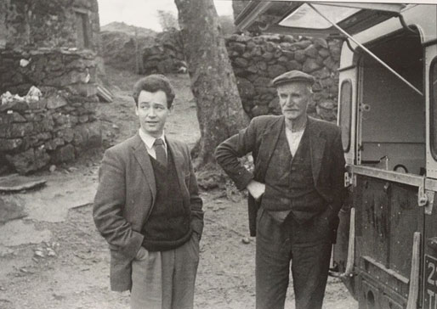
Fig 2. A Young Roy Saer collecting field recordings in 1963
Of all the recordings, I found that of Daff Jones to be the most intriguing– not only because he had lived in the next village to Capel Dewi - Rhydowen, but also because it was my discovery of his song ‘Lannau’r Clettwr’ which had originally spurred my interest in the songs from the area. His recording contained seven beautifully sung songs from the area. Around half I was familiar with, songs such as ‘Y March Glas’, ‘Barf a Locsen’ and ‘Ffarwel I Langyfelach Lon’ which were also noted in ’40 Cardiganshire Tunes’ from Daff’s father, Thomas. Interestingly, Daff noted how the author David de Lloyd had altered some of the words and melodies in this book. Other songs from this recording I had not heard before, including one unusual song which noted the names of a string of local farms and villages – a form of a Welsh songline perhaps. The melody of this tune, along with another ‘Y Bardd A’r Gwcw’ were immensely useful as they provided me with the melodies of songs which I only had words for from books at that point.
The recording of Kate Davies contained nine songs in total, with some similar songs to those of Daff Jones. There were three I had not come across before and two in particular stood out - ‘Caled Yw Fy Nhamed Bara’ and an alternative version of the well known tune ‘Ar Lan Y Môr’. ‘Caled Yw Fy Nhamed Bara’ unfortunately was incomplete, containing only one verse but she did note that it may have been titled ‘Deio Bach’. Much to my satisfaction, I was able to obtain more verses and confirm the name and melody as ‘Deio Bach’ with Kate’s nephew Edgar and he was delighted to hear the recording of his Aunty singing once again. ‘Ar Lan Y Mor’ was called ‘Ar Y Fford Wrth Fynd I’r Farchnad’ and contained different words and an altered melody. Perhaps most interesting about this love song is that the object of the author’s desire is a boy – something highly unusual in Welsh folk music (and folk music in general!).
Megan Tibbott’s recording contained fewer songs than the first two but did relay some interesting oral history and had a few quirky couplets and some songs. Most interesting of these was a sea shanty from Cei Newydd on the coast which she had learned in 1911 from an old sailor called Ben Davies. Like most shanties it is simple in its form, but it is not present as part of J. Glyn Davies’ collection of sea shanties and therefore a valuable recording.
As part of my research into field recordings, I also visited the British Library. There were a series of recordings by Peter Kennedy which I was very eager to hear and was not disappointed. The collection contained around 25 recordings made around Wales during the 50’s and 60’s – some singers in the recordings were very old at the time and so the collection represents in many ways a snapshot of both older folk songs and a singing style which has since been eclipsed by modern pop music and the Bel Canto style of singing of the Eisteddfod. Of the 25 recordings there were a handful of songs which I was able to locate to Ceredigion using the sleeve notes and also the musical notation in Peter’s book - ‘Folk Songs of Britain & Ireland’. The singing style varies widely in the recordings but revealed some interesting elements (see musical analysis)
Of this collection, there were a few songs which I was not familiar with but one song which really stood out was ‘Y Deryn Du’. Although recorded in North Wales all the records of the words of the song in the library note the author as the same as ‘Y Bardd A’r Gwcw’, namely Dafydd Sgbuor from Castell Hywel (which lies about 5 miles from Capel Dewi). Written around 200 years ago, it belongs to a specific sub genre of Welsh folk songs, namely ‘Cân Llatai’. ‘Llatai’ means quite literally, ‘love messenger’. The song is a conversation between a young boy and a blackbird. In a similar vein to ‘Y Bardd A’r Gwcw’, which features a conversation between a man and a cuckoo, in this song a blackbird is giving the young lad love advice. It was most pleasing to be able to find the melody for this song, since all the records of song contained the words had no accompanying melody. This song was also another example of the mixolydian mode, which was unusual.
3.3 Welsh Folk Song Society Journals
Cymdeithas Alawon Gwerin Cymru or The Welsh Folk Song Society was founded in 1906 to collect, preserve and promote traditional Welsh folk music. For a reason unknown to me, as the 20th century drew to a close the society ceased to maintain efforts to collect songs and switched to research and academic study. Despite the immense wealth of material which the society has collected and published in its journals, I find it hard to fathom why they ceased to continue collecting music from the field – especially since my own work has proven that there are still many unrecorded songs extant.
Despite its small membership, the society have managed to collect and publish around 600 pieces unique music to date in their journals. It’s worth noting that these are rarely accessed and mostly gathering dust in the National Library, indeed some were missing. Thankfully with the help of Roy Saer’s detailed notes (he had personally gone through all 111 journals and noted which songs were from Ceredigion!) I was able to photocopy all the songs that the society had published which were relevant to my research. In total this was around 35 songs, which stemmed from a variety of sources. Some noted from recordings which I was already familiar with such as Gwladys Megan Tibbot and others from larger folk song collections such as those of Jennie Williams from Aberystwyth and Soley Thomas from Llanidloes. Others had been collected by society members over the years.
Faced with such an avalanche of music I set about playing through each of them in turn. Some were familiar, others not, but I was particularly seeking out anything which was musically unusual, modal or had escaped the fashions of Victorian music hall singing. Of this collection there were around five songs which really stood out. The first, ‘Broga Bach’ or ‘Little Frog’ was decidedly modal in nature and when played with the simple piano accompaniment sounds quite distinct from other songs in the journals (see my further notes on this). A further beautiful modal melody was ‘Tra Bo Dwr Y Mor Yn Hallt’ – which was of the dorian mode ‘popular in Cardiganshire’ and collected in Llandovery from an old man in 1911 by the collector Soley Thomas.
The third and fourth songs of note from this collection which one could perhaps group together are ‘Y Folantein’ and ‘Yr Eira’. Y Folantein does appear in the additional notes section of J. Ffos Davies’ collection but was also recorded from the Mynydd Bach Area at the turn of the last century. A rare example perhaps of words being written to a tune, it is quite different to a lot of Welsh folk music and more akin to the folk music of Brittany. This rhythmic difference was also notable in ‘Yr Eira’ which was also modal and had a rhythmic lilt which is very reminiscent of Breton dance tunes (see later note on this).
The fifth tune of interest contained four melodic variants. ‘Gwel Yr Adeilad’ was at one point a very popular melody in Wales, both in folk songs and also as adapted melody for hymn singing. It origins lie in the English melody ‘See The Building’, which to my knowledge has now disappeared from the records in England. In Wales it took on a life of its own and had many sets of words set to it with regional variants in melody. The variations in melody perhaps are due to the complexity of the tune.
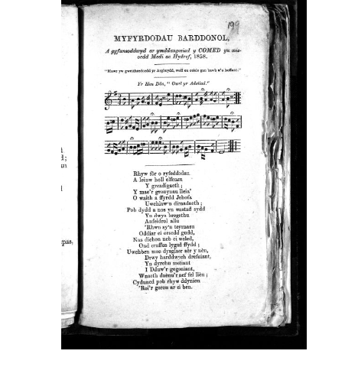
Fig. 3 One of the many variations of the tune ‘Gwel Yr Adeilad’
3.4 Ballad Sheets
Much like the rest of Britain from the late 17th century until the early 19th century, ballad singing in Wales was an immensely popular form of entertainment. It was also a means of income for those who would visit markets and fairs to perform their latest compositions and sell their work - covering topics from the latest news, matters of love and even events such as the strange appearance of Donati’s comet in the night sky during 1858 – as my discovery of a ballad from Pencader to the tune of ‘Gwel Yr Adeilad’ revealed. The advent and accessibility of the printing press made pamphlet printing relatively easy and many thousands of these ballad sheets have survived to provide us with a rich window into lives of every day folk, as well as the musical traditions of this period.
The National Library in Aberystwyth contains around 4-5000 ballad sheets in its archive. Narrowing these ballads down to my focus area of Ceredigion was quite a challenge and I took to using the library search service to enter towns where there were printing presses or known ballad singers. Towns such as Llandysul, Llanybydder, Aberystwyth yielded a fair number of results and I quickly found I had much material to look through.
Ballad singers would more often than not use and adapt existing melodies rather than compose new ones. After all, it would help them sell their songs if punters were already familiar with the tune. As I browsed the results, it became apparent to me that the challenge would not be finding unusual stories or unsung songs, but matching melodies to the words. Some of the ballads made note of the ‘Tôn’ or melody of the ballad but many did not. Even where the melody was noted, quick Google search results revealed that information was scarce. Some of the Welsh melodies such as ‘Bugeilio’r Gwenith Gwyn’ and ‘Ar Hyd Y Nos’ are still sung today, however others such as ‘Caru’r Lleuad’ or ‘Galar Don’ returned no results when searched on Google or in the Library. Many of the ballad tunes also had English titles. Melodies such as ‘Nutting Girl’, ‘Belisle March’ ‘Sweet Home’ and ‘Wait For The Waggon’ were clear adaptations of English melodies put to Welsh words.
Feeling slightly overwhelmed with the amount of potential research, I decided to concentrate on a few local ballads which had caught my eye and try to locate the melodies. I also managed to locate three sources of crucial information – namely a dissertation on the Welsh ballad tradition by Gwawr Eleri Jones with a list of melodies, an out of print book by the author Tegwyn Jones ‘Hen Faledi Ffair’ which contains some previous work on ballad/melody matching, and ‘Welsh Traditional Music’ by Phillys Kinney which is pretty much the only comprehensive book on Welsh folk music. Between these three sources and some online research I managed to locate some elusive melodies such as ‘Robin Yn Swil’, ‘Roslyn Castle’, and ‘Diniweidrwydd’.
Robin Yn Swil was quite Victorian in style and the local ballad which I found from Llanarth which notes this melody is highly unusual among the collection. A promotional leaflet for the land reform movement of the late 19th century which advocated three acres of land and a cow for every person, ‘Tair Erw A Buwch’ is a rousing call to arms which has a real charm to it. The second ballad which struck me and is sung to the tune of ‘Roslyn Castle’ is it seems is Scottish in origins but was adapted to fit the words of ‘Dai’r Cantwr’ who was imprisoned in Carmarthen and deported to Australia following his part in the Rebecca Riots of the mid 19th century. Lyrically moving and melodically quite adventurous, this song stands out as a personal lament and I have been told it is rare to find a ballad writer writing about themselves in such a reflective manner.
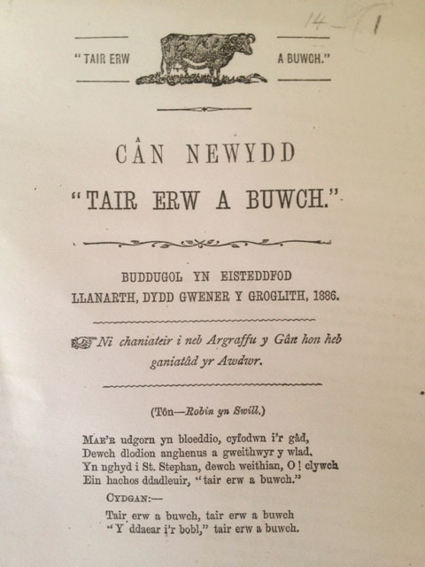
Fig 4. The ballad ‘Tair Erw A Buwc’ or ‘Three Acres And A Cow’ after the land reform campaign of Eli Hamshire in the 1880’s
The melody of ‘Diniweidrwydd’ was noted alongside quite a few ballads but the one which struck me was that of David Jones Llanybydder and his account of the effect cholera was having on rural populations. At seventeen verses long it must have been quite an epic and sad performance when originally sung. It seemed to me at the time that there must be more than one melody called ‘Diniweidrwydd’ as other songs such as ‘Deio Bach’ which note this melody have different syllabic content and is very different in sound. My later discovery of three different versions of this melody in the Ifor Ceri manuscripts confirmed this theory.
Despite the lack of information and many dead ends, it was most satisfying for me to be able to find a rare melody and match it to the original words. There’s a certain magic that happens when you realise that the syllabic content of the words and music match and that you might be the first person to have sung this particular song in several centuries. It was also pleasing that I was able to obtain melodies from people such as Iwan who perhaps may be the last person alive who remembers that particular tune. Iwan’s emphasis on the words and the sheer volume of verses contained in the ballads in the archive led me to realise that in the Welsh folk tradition, words are incredibly important. Poems often are the origin of a song and the most popular melodies fit well with the syllabic traditional Welsh poetic metres. The Welsh are born storytellers and as Robyn Tomos reminded me; “the melody is simply a vehicle for the words. “
3.5 Books
In recent years, a few books and collections of Welsh folk music have either been released or re-published and there is now thankfully more information available to the public than ever before . Finzi funding was immensely useful in allowing me to obtain a number of books without worrying too much about the expense. One book such as Peter Kennedy’s ‘Folk Songs of Great Britain and Ireland’ I had to order from the States, whilst others were out of print and therefore in the hands of private collectors and niche book shops. Some such as ‘Hen Faledi Ffair’, ‘Cerddi Digri’ and ‘Cerddi’r Ddau Frawd’ I waited patiently to appear on eBay, whilst others were gifted to me by people who were encouraged by the work I was doing. It was also useful to be able to compare versions of melodies between books, read more about the history of the song, collectors context and cultural significance of folk music in Wales.
One pivotal book in my research was 40 Cardiganshire Tunes, published in the 1940’s by David de Lloyd and now out of print. Although the material was taken from J. Ffos Davies’ collection and altered in places, it allowed me to scan through an impressive amount of songs taken from the local area in standard notation. J. Ffos Davies’ collection is all notated in Sol-Fa and so a musical comparison will perhaps have to wait for another time (when I may perhaps learn sol-fa properly!).
Another useful book was ‘Canu’r Cymry 1&2’ which was recently re-published by the late great Mered Evans and Phillys Kinney. This book contains a lot of the songs from the Welsh Folk Song Society journals and some additional ones from collections such as ‘Myn Mair’ – given the restrictions on accessing some collections, this was very useful. Peter Kennedy’s book was also immensely useful in this regard, as it allowed me to compare his notation with those of the recordings and is the only public place where one may access the songs outside of the British Library.
Interestingly, local history books also yielded some gold. ‘Hanes Llandysul’ or ‘A History of Llandysul’ contained a unique collection of local history, customs, stories, verses and song. One song in particular ‘Can Dyffyn Clettwr’, originally by David Rees of Talgarreg tells the story of ‘y fab afradlon’ or the prodigal son from the Clettwr valley (the very same as Capel Dewi) who leaves his home to become a sailor and finds that he has longing for the comforts of home. As far as I’m aware this is the only place this song is noted. Other books such as Kate Davies’ ‘Hafau Fy Mhlentyndod’ and Audrey Martin’s ‘Hanes Llwynrhydowen’ were also useful sources of local information, with Audrey Martin’s book containing the song ‘Dyffryn Clettwr Fach’ or ‘Little Clettwr Valley’ which tells the stark sad tale of a girl forced to leave her community due to an illegitimate pregnancy. I was quite shocked by the content of this song and it goes to show that folk music can sometimes be quite stark.
Other books of note which yielded lost versions of songs include the very old books ‘Diliau’r Awen’ and ‘Crwth Dyffryn Clettwr’, which contained many old sad and religious ballads (many to the tune of ‘Gwel Yr Adeilad’. Also ‘Cerddi Digri A Rhai Pethau Eraill’ and ‘Gemau Ceredigion’ which had ballads from the turn of the last century, some of which with more modern melodies such ‘Solomon Levi’ and ‘I Love A Lassie’. Being able to browse through these books gave an interesting overview of the evolution of folk singing and musical fashions over the centuries and took me right up to the point when radio and television arrived and communal singing traditions began to decline.
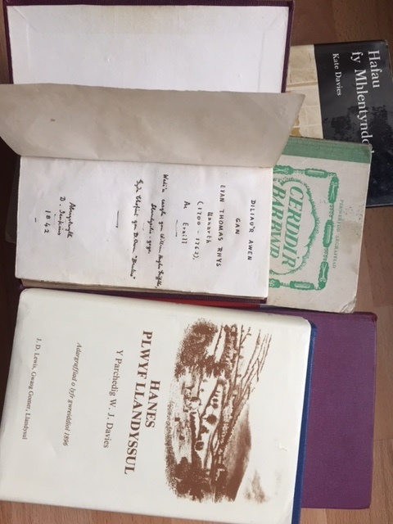
Fig. 5 – Some key books
3.6 Collections
J. Ffos Davies
As previously noted, J. Ffos Davies of Ffosesbog, Prengwyn collected a wealth of songs from the Clettwr, Cerdin and Teifi valley area over a number of years. His notes reveal a treasure trove of local history and indeed many of the songs are well known in the area to this day. Perhaps most interesting amongst this collection is ‘Y Folantein’. This song is also noted in the Welsh Folk Journals and is not only is melodically unusual but rhythmically challenging with short bursts of lines delivered in quick succession. Many of the songs in J. Ffos Davies’s collection which were musically ‘re-arranged’ and published by David de Lloyd, with some of the more words risqué altered by Cledlyn Davies. ‘Y Folantein’ is not one of them. Meinir Angharad Jones has an thorough paper on which critiques David de Lloyd’s arrangements and compares them with the originals. As a non sol-fa reader I was unable to verify the accuracy of her critique but it seems personal interpretation amongst song collectors and publishers was common. The fact that de Lloyd never credited J. Ffos Davies as the source of his book perhaps speaks volumes.
Myra Evans
Myra Evans of Cei Newydd died in the 1970’s but before she died was able to record document a treasure trove of local folk tales, stories and songs. Unfortunately I was not able to access the audio recordings of her singing in the archives at St. Ffagans and was left to read through her notes in the National Library. One frustrating result of this was that I could not make copies of the music to study and since humming to oneself is not particularly acceptable in a public library I was left quite frustrated. To add to my frustrations, the library did not know who owned the copyright and I took it upon myself to find some of Myra’s descendants (if there were any) and obtain permission to make copies of her work. After much digging I managed to find the name of her daughter, the late Iola Billings, whom I traced to a church in Leicester and via the church email list, finally her son David. He was happy to help I was thankfully finally able to make copies of her music.
One song in particular in the collection ‘Myn Mair’ is astonishingly unique. Stemming from the pre-reformation period it must be at least 500 years old and was a song sung at ‘gwylnos’ which took place the night before a funeral. The catholic content of the lyrics meant it was sung in secret for almost this entire period! That it survived is nothing short of miraculous. It is a lament which is melodically distinct, haunting and stunningly beautiful. I consider it a jewel in the crown of Ceredigion’s folk heritage.
Ifor Ceri (or John Jenkins)
A folk song collector of the late 18th century, Ifor Ceri travelled around much of Wales collecting and writing down folk songs, hymns and poetry. He was a strong advocate of Welsh culture and key figure in re-establishing the National Eisteddfod. There are two large volumes by him called ‘Melus Seiniau’ and ‘Melus Ceinciau’ housed in the National Library which contain hundreds of melodies collected around the beginning of the 19th century. The collection is a fascinating historical artefact and the origin of many airs and melodies. I spent many hours trawling through the collection looking for material from Ceredigion which might be musically of interest. After the many thousands of words in the ballad sheets I hoped at least to be able to fill some of the missing melodies which had seemingly disappeared.
My first ‘eureka’ moment was coming across a tune with a few scattered words called ‘Hen Garol Haf’ or ‘Can I Glod I’r Haf’ (Ode To Summer), which rang a bell from a melody noted in a ballad in the old book ‘Diliau’r Awen’ of the same period. Noted as being sung in Ceredigion, I quickly found the book and worked to see if the words and music matched. What joy to discover that they matched perfectly! It must be said that the tune is not the most exciting but this discovery gave me great encouragement. I was also able to locate another ‘lost’ ballad melody from the same book called ‘Spanish Minuet’ which was the melody of ‘Penillion’ (or verses) to a valentine.
Amongst the other songs of interest from Ceredigion in the collection was ‘Lliw’r Ceirios’ (The Colour of Cherries), which is in the rare aeolian mode and has a much older sound to it when compared to the rest of the collection.
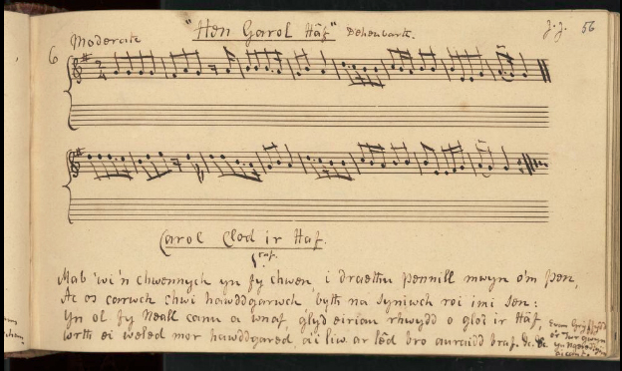
Fig. 6 – ‘Hen Garol Haf’ or ‘Carol Clod I’r Had’ (An Ode to Summer) from the Ifor Ceri collection

4. Further Musical Analysis
My father recalls the renowned harpist Osian Ellis once telling him the story of his conducting of a congregation in North Wales during the 1940’s. He told of his frustrations trying to get them to sing the sharpened seventh degree of the scale. As he recalled ‘they were singing in between the notes’ i.e. between the natural flattened seventh of the harmonic series and the raised seventh. He concluded that they were still stuck in the more modal form of singing akin to folk music and had not yet adjusted to demands of more modern European harmony. Quite amazing when considering that Welsh hymn writers had been using Bach harmony for a few centuries by the 1940’s!
To a degree, my findings confirm the tendency to use a flattened 7th amongst some the singers of rural Wales. ‘Y Deryn Du’ on the Peter Kennedy recordings from the 1950’s clearly shows an ambivalence in this area of the scale which one cannot simply attribute to bad singing. Likewise the singing of Calfin Griffiths in ‘Y Garreg Wen’, which is less ambivalent clearly features a flattened seventh. There is also the piece ‘Broga Bach’ in F major with its unexpected Eb which changes the nature of the piece completely (one listen to the English equivalent of this melody shows how much it has morphed). To my knowledge, there is only one Welsh folk tune extant in the popular canon which uses the mixolydian mode - ‘Lisa Lân’. Most of the perceived ‘traditional’ Welsh music is quite modern in sound and there are even those to this day who challenge the use of the mixolydian mode at all in Welsh folk music, and so I am glad to be able to challenge this viewpoint with my research.
Equally rare it seems is the use of the Aeolian mode with its flattened 6th degree. The four songs on my list ‘Myn Mair’ and ‘Can Dyffryn Clettwr’ and ‘Y Foltantein’, and ‘Lliw’r Ceirios’ all feature this mode but I they have all pretty much disappeared from living memory and I cannot recall one popular Welsh folk tune which uses this mode. The fact that ‘Myn Mair’ was sung before a funeral might indicate perhaps that the sound of this particular mode was reserved for sad and poignant occasions and one does wonder whether these songs disappeared from oral memory and popular culture because they sounded dark and slightly unhinged. The same cannot be said for the Dorian mode, which is perhaps less gloomy. ‘Lannau’r Clettwr’, ‘Tra Bo Dwr Y Mor Yn Hallt’, ‘Yr Eira’ are all in the dorian mode and it is a sound prevalent in Welsh folk music and hymn writing to this day.
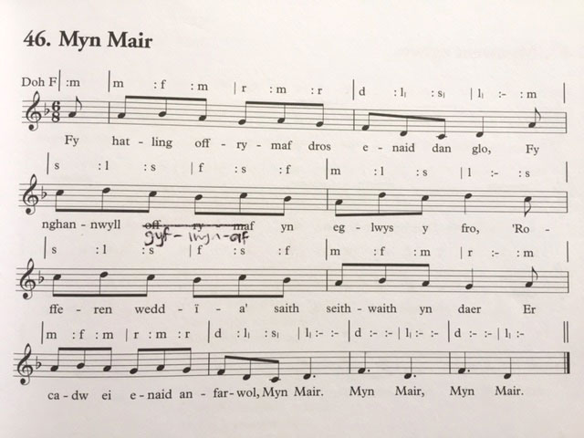
Fig.6 – The hauntingly beautiful ‘Myn Mair’.
In the context of this field, one must bear in mind that by the end of the 19th century the upbeat sophisticated sing-along styles of the music hall had swept the country. Coupled with the widespread availability of the upright piano they offered a brighter, more accessible and frivolous means of communal singing. One cannot blame people for aspiring to a more modern, hopeful future – even if it led to the demise of the older melodies and styles of singing. The remnants of this period are to be heard everywhere in Welsh music in general. I personally don’t care much for this style of music and some might challenge whether it should be counted as ‘folk music’, but it felt important to be able to record the songs which had not yet been collected - particularly ‘Cerdin’, ‘Dafydd Jones o Fwlch Y Llan’, ‘Y Filltir Aur’ and ‘Y Crwydryn’.
Further afield, the melodic and rhythmic anomalies in songs such as ‘Gwel yr Adeilad’ and Roslyn Castle can probably be attributed to the fact that they travelled from outside Wales. The melody of ‘Gwel Yr Adeilad’ is highly unusual, modal in nature and switches between Aeolian and Dorian mode – there are also half bars and some unusual timings and accenting which make it quite a difficult song to perform to this day. I must have come across at least six variations of this melody. Roslyn Castle is Scottish in origin and there are a few variations of this song which contain unexpected accidentals. Which one was used in Wales is difficult to know but it remains musically unique in the Welsh folk cannon.
As previously noted, song collectors and publishers are usually not the song bearers themselves and thus material is open to personal interpretation, musical fashion and ‘correction’. For example, the notation of ‘Y Deryn Du’ in Peter Kennedy’s book does not include the ambivalent 7th and has been rounded down. Ifor Ceri’s manuscript is suspiciously lacking in many of the folk tunes which have survived in oral memory to this day and many of the tunes are quite plain in style. As a Welsh priest, one does wonder whether the slightly puritanical mindset of the time may have affected both his choice of songs and the notation. Without access to original recordings of the singers, it is impossible to know how much the collector’s musical prejudices affected the notation we are left with today. Therefore it feels important to question the accuracy of any notated piece of music and be open to experimentation when playing if it feels appropriate.

5. Conclusions
On sitting down to conclude my research, I realised that one of the reasons my net ended up cast so wide was that I had not defined very clearly what might define a ‘lost’ or ‘rare’ song. Certainly songs such as ‘Dafydd Jones o Fwlch Y Llan’ and ‘Lannau’r Clettwr’ come into this category but the many lyrical variations of melodies such as ‘Gwel Yr Adeilad’ may perhaps not. A song which only one remaining person can remember is clearly very precious, but so is one which lies in an out of print book of which only a handful of copies remain. One could categorise songs as being published, published but also out of print or inaccessible (as is the case with the audio archive in St. Ffagans). There is also the question of whether the song is in oral memory or being actively sung.
To help clarify and organise the material I have collected, I have prepared a table which helps categorise the songs of note which I found of import or interest. From glancing at the colour coding, it’s evidently clear that there are a host of folk songs from Ceredigion which have either never been published or are now out of print. Myn Mair is an interesting example of a song which had almost passed out of existence, but has since gained in popularity since being published and one wonders whether better access and availability of these songs would help in supporting Wales’ folk culture.
If anything, my scholarship has proven that the folk music of Wales is a neglected field in need of new blood, funding and input. The amount of interesting material from outside of Ceredigion which I left out is substantial, and in the context of Wales as a whole the work presented here is just the tip of an iceberg. It seems to me that time is also of the essence - one of my major regrets in doing the work was not being able to hear ‘Canu Pwnc’ live. I did manage to find a recording on a compilation CD compiled by Ceri Rhys Matthews but my attempts to hear it in person bore no luck. The vicar of Llandysul church, Beth Davies remembers it being sung but informed me that they had now ceased to sing it there. She informed me that the single remaining place still singing now is in Pembrokeshire. The only local with a thorough knowledge of the singing – the ‘codwr canu’ (singing raiser) was very ill in hospital and it appears he may be the last person in Ceredigion with this knowledge.

Song Name | Source | In Oral Memory | Melody Noted | Melody Published | Words Recorded | Words Published | In/Out of Print | In Library
Lanau’r Clettwr | Daff Jones | No | Yes | No | No | No | Never printed | No
Dafydd Jones o Fwlch Y Llan | Iwan Bwlchyfadfa | Yes | No | No | Yes | Yes | Out of print | No
Y Crwydryn | Iwan Bwlchyfadfa | Yes | No | No | Yes | Yes | Out of print | Words
Y Garreg Wen | Calfin Griffiths | Yes | No | No | Yes | Yes | Out of print | Words
Cerdin | Calfin Griffiths | Yes | No | No | Yes | Yes | Out of print | Words
Y Filltir Aur | Calfin Griffiths | Yes | No | No | Yes | Yes | Out of print | Words
Yr Hen Feinar | Calfin & Iwan | Yes | No | No | Yes | Yes | Out of print | Words
Ar Y Fford Wrth Fynd I’r Farchnad | Kate Davies | No | Yes | No | No | No | Never printed | No
Caled Yw Fy Nhamed Bara (Deio Bach) | Kate Davies | Partially | Yes | No | Yes | No | Never Printed | Words
Gwaralltryn a Gwardafolog | Daff Jones | No | Yes | Yes | Yes | Yes | In print | Yes
Shanti Môr (Sea Shanty) | Megan Tibbott | No | Yes | No | No | No | Never printed | No
Y Deryn Du | Peter Kennedy | No | Yes | Yes | Yes | Yes | Out of print | Words
Myn Mair | Myra Evans | Revived | Yes | Yes | Yes | Yes | In print | Yes
Broga Bach | Welsh Folk Journals | No | Yes | No | Yes | No | Never printed | Yes
Tra Bo Dŵr Y Mor Yn Hallt | Soley Thomas | No | Yes | No | Yes | No | Never printed | Yes
Y Folantein | J Ffos Davies | No | Yes | No | Yes | No | Out of print | Yes
Yr Eira | J Ffos Davies | No | Yes | No | Some | No | Never printed | Yes
Clod I’r Haf (Carol) | Ifor Ceri / Diliau’r Awen | No | Yes | No | Yes | Yes | Out of print | Yes
Penillion (I Folantein) | Ifor Ceri / Dilau’r Awen | No | Yes | No | Yes | Yes | Out of print | Yes
Lliw’r Ceirios | Ifor Ceri | No | Yes | No | Yes | No | Out of print | Yes
Cân Dyffryn Clettwr | Hanes Llandysul Book | No | No | Yes |  | Yes | In print | Words
Y Bardd A’r Gwcw | Hanes Llandysul Book | No | Yes | No |  | Yes | In print | Words
Proffwydaeth y Bardd | Diliau’r Awen | No | No | Yes | Yes | No | Out of print | No
Comed | Ballad Sheet & Journals | No | Yes | No | Yes | No | Never printed | Yes
Tair Erw A Buwch | Ballad Sheet | No | Yes | No | Yes | No | Out of print | Yes
Caniad Dai’r Cantwr | Ballad Sheet | No | Yes | Yes | Yes | No | Never printed | Yes
6. List of Songs
7. Bibliography
40 Cardiganishire Tunes – David de Lloyd
Abel Jones. Bardd Crwst – Tegwyn Jones
Alawon Gwerin Iolo Morganng – Leila Salisbury
Alawon Fy Ngwlad Vol. 1 – Nicholas Bennett
Ancient and National Airs of Gwent and Morgannwg – Maria Jane Williams
Ar Dafod Gwerin – Tegwyn Jones
Ar Fanc Sion Cwilt – J. Tysul Jones
Baledi Morgannwg – Ben Bowen Thomas
Baledi Ywain Meirion – Tegwyn Jones
Baledi Yng Nghymru – Mary Ann Constantine
Caneuon Llafar Gwlad (Songs From Oral Tradition) Vol. 1 – Roy Saer
Caneuon Llafar Gwlad (Songs From Oral Tradition) Vol. 2 – Roy Saer
Caneuon Traddiodiadol y Cymry – Welsh Folk Song Society
Canu At Iws (Ac Ysgrifau Eraill) – Roy Saer
Canu’r Cymru 1 & 2 – Meredydd Evans & Phillys Kinney
Casgliad O Len Gwein Sir Gaerfyrddin – Y Parch D.G. Williams
Cerddi’r Barbwr – Jack Oliver
Cerddi Coynant – Evan Jones
Cerddi Crwys – Detholiad Cyf. 1 – Gwasg Aberystwyth
Cerddi Kate Davies – Kate Davies
Cerddi’r Ddau Frawd – Jack H. Davies & Jacob Davies
Cerddi Digri A Rhai Pethau Eraill – Idwal Jones
Cerddi Edern – J. Glyn Davies
Crwth Dyffryn Clettwr – Rees Jenkin Jones
Dail Y Dderwen – W.J. Richards
Dic Dywyll Y Baledwr – Hefin Jones
Diliau’r Awen – E.T. Rhys
Drych Y Baledwr – Ben Bowen Thomas
Folk Songs Of Great Britain & Ireland – Peter Kennedy
Ffylantin-tw! – Cymdeithas Alawon Gwerin Cymru
Gemau Ceredigion – The Educational Publishing Company, Cardiff
Hafay Fy Mhlentyndod – Kate Davies
Hanes Llwynrhydowen – Aubrey J. Martin
Hanes Plwyf Llandysul – Y Parch W. J. Davies
Hen Alawon, Carolau a Cherddi – John Owen
Hen Benillion – T.H. Parry Williams
Hen Faledi Ffair – Tegwyn Jones
I Fyd Y Faled – Dafydd OWen
Pelydrau Ceredigion – Cynfelin
Pennill A Thonc – W.R. Evans
Pennillion Y Plant – T. Llew Jones
Pen And Plough – Diarmuid Johnson
Tafell o Ddyffryn Teifi – Alun L. Jones
Tanau Teifi – Leslie Harris
Telyn Ceredigion – Evan Lewis
Welsh Sea Shanties- J Glyn Davies
Welsh Traditional Music – Phillys Kinney
Welsh Folk Song Society Journals
Y Bibell Glai – T. Elfyn Jones
CD’s
FTX – 005 – Ambell I Gan (Topic Records)
Rough Guide to the Music of Wales – Compiled by Ceri Matthews
Carolau Ceredigion
Melangell , Carn Ingli - Llio Rhydderch
Enlli – Llio Rhydderch
Gwenllian – Llio Rhydderch
Other Sources of research/reference
Y Wasgod Goch (Tape) – Robin Gwyndaf
Docgrooms.com (Online Resource of researcher Chris Grooms)
Spotify
Youtube

